**SOFTWARE ENGINEERING ASSIGNMENT**

NAME : JAHNAVI HEGDE

ROLL NO : 21BCS044

**INTRODUCTION**

In order to move towards a greener and more sustainable future, the energy sector is currently undergoing a fundamental transition. As the world struggles to address climate change and achieve the goal of a decarbonized energy model, digitalization has come to be recognised as a crucial enabler to see that this transformation is realised. To increase energy efficiency, businesses have started switching from analogue metres to digital meters, smart meters, and other digital technologies over time. The renewable energy industry still has to contend with a number of challenges, including geographically dispersed energy data, a lack of integrated platforms, the inability to manage assets, and the absence of specific, verifiable goals.

The integration of renewable energies, energy regulations, and transparency in their management can be facilitated by digitalization provided it is carried out under the direction of an integrated operations platform. Additionally, it can help optimise the production of renewable energy sources, forecast weather and market conditions more precisely, and decrease downtime by providing alerts based on predictive maintenance. Furthermore, automated procedures for wise decision-making and optimisation can be built into renewable energy plants using digitalization tools and platforms. These advantages highlight the potential of digitally based future energies, where new power plants are digitally designed from the ground up and supported by digital twins for maximum performance from power generation through its connection with customers.

**Requirements:**

The following requirements are necessary to develop a suitable technology-oriented digital solution for the energy sector:

a. An integrated platform that can connect and manage assets, as well as provide real-time monitoring and analysis of energy generation and consumption.

b. Smart metres and sensors that can collect and transmit energy data from various sources in a secure and efficient manner.

c. Artificial intelligence and machine learning tools that can provide accurate forecasting of weather and market conditions, optimise energy generation, and improve maintenance processes.

d. Cybersecurity measures that can ensure the protection of sensitive data and prevent potential cyber threats.

e. Scalability and flexibility to adapt to changing energy demands and regulations.

f. The capacity to communicate and integrate seamlessly with existing energy infrastructure and systems.

g. User-friendly interfaces that make it simple for consumers and energy providers to access and view energy statistics.

h. Specific, traceable goals that support the energy sector's broader decarbonization and sustainability objectives.

i. Tools for advanced analytics and data visualisation that can offer insights into patterns of energy use, spot inefficiencies, and suggest steps to optimise energy use.

j. Digital twins, which can assist with modelling, forecasting, and testing for optimal performance, from power generation to its connection to the customers, are item no.

**Tools and Technologies** :

a. Energy management systems (EMS) that can collect, analyze and manage energy data from various sources.

b. Internet of Things (IoT) devices, including smart meters, sensors, and actuators, that can monitor and control energy usage in real-time.

c. Artificial intelligence and machine learning tools for energy forecasting, predictive maintenance, and asset optimization.

d. Blockchain technology for secure and transparent data management and transactions.

e. Cloud computing platforms for scalable and flexible energy management and data storage.

f. Cybersecurity solutions such as firewalls, encryption, and intrusion detection systems to protect against cyber threats.

g. Geographic information systems (GIS) for spatial analysis and visualization of energy data.

h. Energy trading platforms for market-based optimization of energy generation and consumption.

**3.API code**

import requests

import pandas as pd

# Define API endpoint and parameters

url = 'https://developer.nrel.gov/api/pvwatts/v6.json'

params = {

'api_key': 'YOUR_API_KEY',

'lat': 37.7749,

'lon': -122.4194,

'system_capacity': 10,

'module_type': 0,

'losses': 14,

'array_type': 0,

'tilt': 30,

'azimuth': 180,

'dataset': 'tmy3'

}

# Send request to API and get response

response = requests.get(url, params=params)

data = response.json()

# Convert data to pandas DataFrame

df = pd.DataFrame(data['outputs'])

# Perform data analysis

print(df.describe())

**Output:**

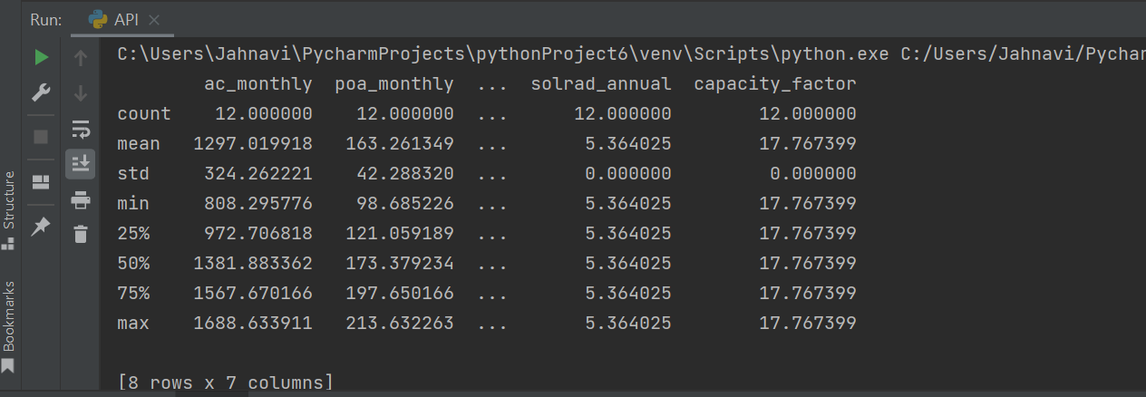

This code makes a request to the NREL (National Renewable Energy Laboratory) API endpoint for the PVWatts version 6 API. The API allows users to estimate the energy production and cost of energy of grid-connected photovoltaic (PV) energy systems based on a few inputs, such as location, system capacity, module type, and others.

The code defines the parameters for the API request, including the API key, the location (latitude and longitude), system capacity, module type, and other parameters. Then, it sends a GET request to the API using the ‘requests’ library and gets the response in JSON format.

After that, the code converts the JSON response to a pandas DataFrame using the ‘pd.DataFrame()’ function, and performs data analysis on the DataFrame using the ‘df.describe()’ function. The ‘describe()’ function calculates summary statistics for the DataFrame columns, such as mean, standard deviation, minimum, maximum, and quartiles.